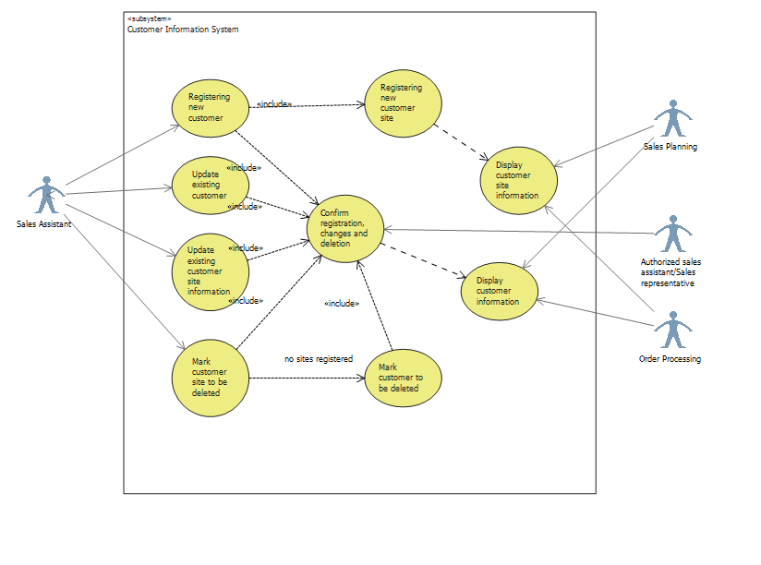

|  |  |
| --- | --- |
| **Use Case** | Update existing customer |
| **Actor:** | Sales assistant |
| **Pre condition:** | potential customer contacts Lahjapaja or Lahjapaja contacts potential customer |
| **Goal:** | Acquiring information about the customer and preparing it for the final acceptance of relationship with him |
| 1 | Sales Assistant inserts company name, invoicing and delivery address, contact person information (name, tel. number, email, address), way of delivery, other possible info |

|  |  |
| --- | --- |
| **Use Case** | Registering new customer |
| **Actor:** | Sales assistant |
| **Pre condition:** | Potential customer contacts Lahjapaja or Lahjapaja contacts potential customer. |
| **Goal:** | Acquiring information about the customer and preparing it for the final acceptance of relationship with him. |
| 1 | Sales Assistant inserts company name, invoicing and delivery address, contact person information (name, tel. number, email, address), way of delivery, other possible info. |
| 2 |  |
|  |  |
|  |  |
|  |  |
|  |  |
|  |  |
|  |  |